[1]

Investigation of Long Memory in Quarterly Home Price Index Data

Vikas Garg, Yasin Khan, Shirley Lu, Timothy Roberts, Yifan Tang, Wesley Tillu

*Abstract*—…………………………………………………………………………………………………………………………………………………………………………………………………………………………………………………………………………………………………………………………………………………………………………………………………………………………………………………………………………………………………………………………….………………………………………………………………………………………………………………………………………………………………………………………………………………………………………………………………………………………….………………………………………………………………………………………………………………………………………………………………………………………………………………………………………………………………………………………….………………………………………………………………………………………………………………………………….

I

# INTRODUCTION

N

# Time Series Modeling

## Stationarity

2.1



## Unit Root Non-Stationarity

## ARCH Effect

## Long Term Dependence

## Proposed Models

2.2



# Methods

## Data

## Initial Analysis

### Exploratory Data Analysis

### Data Transformations

Many parameter estimators are based on the assumption of Gaussian distribution. In particular, the Whittle estimator for the fractional differencing parameter is one such estimator. The Whittle estimator is generally preferred over other fractional differencing parameters as it is consistent, unbiased, and asymptotically efficient.

The Box Cox transformation aims to apply a power transformation to ensure that the data follows an approximately normal distribution. The Box Cox transformation stabilizes variance and induces homoscedacity in the time series. It is defined as

$$y^{(λ)}=\left\{\begin{aligned}\frac{y^{λ}-1}{λ}, λ≠0 \\ \log\left(y\right), λ=0\end{aligned}\right.$$

In practice, the observation $y$’s must be strictly positive. The simple returns series of the state-level housing price data include negative data points and thus, the absolute value of the minimum observed data value plus a small epsilon was added to each data point.

If the return series failed prior tests of normality, the Box Cox test was used to estimate the appropriate power of $λ$ along with its standard error. Then, the interval ($λ±std.error$) was evaluated to determine the power to apply. If the interval contained 0, a log transformation was used. Otherwise, the estimate or its closest fraction was used to transform the data.

The effectiveness of the data transformation was tested graphically with density plots and statistically using formal normality tests.

A weakness of the Box Cox transformation is that if the true distribution is far from Gaussian, there will not exist a sufficient $λ$ that will make the data normal. However, even in cases where no power transformation could bring the distribution to exactly normal, the usual estimates of $λ$ will lead to a distribution that satisfies certain restrictions on the first 4 moments, thus will be usually symmetric.

### I(1) Testing

### Normality Testing

## Parameter Estimation for Model Building

### Parametric vs Non Parametric vs Semi-parametric

### Linear Time Series Parameters

### Nonlinear Time Series Parameters

### Fractional Differencing Parameters

### Joint Estimation of ARFIMA Parameters

## Model Checking and Performance

### Absolute

### Relative

# Results

## Initial Analysis

### Exploratory Data Analysis

### Data Transformations

Analysis of the states demonstrated that the distribution of the returns deviates too far from Gaussian and thus, any Box Cox transformation attempt fails. Figure 4.x shows graphical results from before and after the transformation for Arkansas and Table 4.x. shows numerical results.

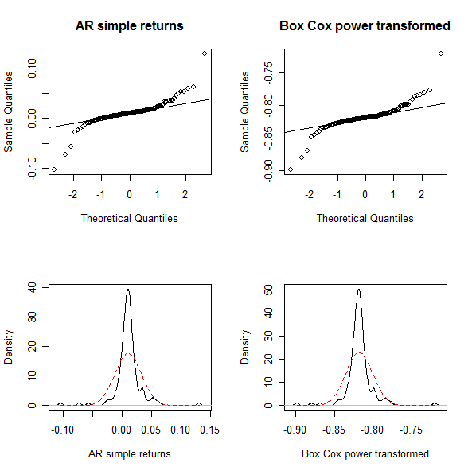

**Figure 4.x: QQ plots and density plots of the Arkansas simple return series (left) and the Box Cox transformed series with $λ$ =1.11 (right)**



**Table 4.x: p-values from normality tests for the Arkansas simple return series and the Box Cox transformed series with $λ$ =1.11 (right)**

The QQ plots and density plots show significant departures from normality. The p-values of various normality tests strongly suggest non-normal distributions. It is concluded that a Box Cox transformation is inadequate in making the return series Gaussian.

### I(1) Testing

### Normality Testing

## Parameter Estimation for Model Building

### Parametric vs Non Parametric vs Semi-parametric

### Linear Time Series Parameters

### Nonlinear Time Series Parameters

### Fractional Differencing Parameters

### Joint Estimation of ARFIMA Parameters

## Model Checking and Performance

### Absolute

### Relative

## Validity and Interpretation

# Conclusion

Acknowledgment

References

1. T. J. Barstow and Paul A. Mole. “Linear and nonlinear characteristics of oxygen uptake kinetics during heavy exercise,” American Physiological Society.
2. Stephen Steiler. “The Lactate Threshold.” http://home.hia.no/~stephens/lacthres.htm
3. Stirling, J. R., Zakythinaki, M., Refoyo, I., and Sampedro, J. “A Model of Hear Rate Kinetics in Response to Exercise.” Journal of Nonlinear Mathematical Physics. Vol 15. 2008
4. Tsay, R. S. *Analysis of Financial Time Series: Second Edition.*

1.